THE SUNPENDULUM PROJECT

by Hofstetter Kurt

THE SUNPENDULUM CONCEPT (Hofstetter Kurt, 1997)

As time goes by that means with the rotation of earth sunlight wanders it’s way to earth. A continous circulation of light and shade – day and night – in parallels.

In 12 time zones around the earth videocameras are directed towards the sky and online connected to the InterNet.12 videocameras – time-eyes – around the earth watch the sky – INPLUSION.

At a certain place on earth 12 screens are setup in a circle within a pavillon. Those screens are connected online via the InterNet with the 12 time-eyes and transmit the sunlight from the 12 time zones – EXPLOSION.

A sunclock is being created.

With the rotation of earth, that means over time, the sunlight is moving within the circle of the screens. In the inner circle day and night can be experienced in parallels at the same time.
THE SUNPENDULUM INPLUSION (realized August 2006)

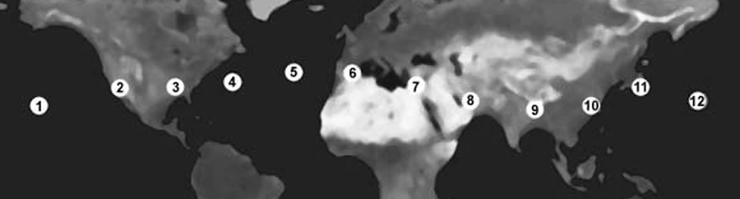

- permanent installation of Sunpendulum Time-Eyes / videocameras in (1) Hawaii - USA, (2) Ensenada - MEX, (3) New Orleans - USA, (4) Bermuda - GB, (5) on the Azores - P, (6) Granada - E, (7) Cairo - ET, (8) in Dubai - UAE, (9) Calcutta - IND, (10) Hong Kong - PRC, (11) Tokio - JP and (12) on the Marshall Islands - RMI.

THE SUNPENDULUM EXPLOSION (realisation in progress since 2001)

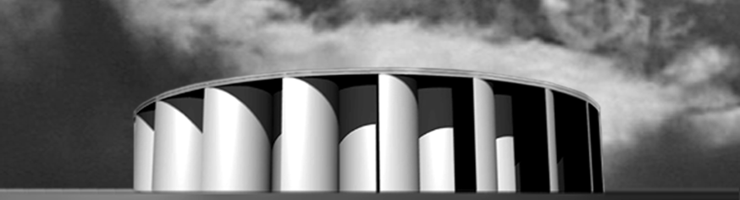

- permanent installation of Sunpendulum-Pavilions in public space housing the circle of the 12 video monitors online connected with the 12 Time-Eyes. Without any entrance fee any pavilion is 24 hours open and accessible from all directions. Its panels optimize the inner light for the screens with no direct sunbeam reaching the circle of the screens.
Since 1991 the artistic work of Hofstetter Kurt has focussed on parallelism and circulation, sky, light and time resulting in media art installations like “Im Augenblick” (Vienna, 1992), internet sculptures like “The Complementary Light Pendulum” (in progress since 1994) and “moving moments@pendel” (Vienna 1996) leading to the project Sunpendulum. In 1997 Hofstetter Kurt released the concept of the Sunpendulum project. With public and private support he was able to start with the realisation in 1998. From its nature the realisation is based on interdisciplinary cooperation in Arts and Science as well as on the assistance of a whole host of people and close collaboration with partners around the earth.

The steps towards realisation have been accompanied by a PARALLEL MEDIA project – a parallel process of presentation, documentation and reflection by Barbara Doser and Hofstetter Kurt. Parallel artistic works reflect central topics like parallelism and circulation, light and shade and time. Along with the media of Video, CD-Rom, Photography, Print, Mixed-techniques it has been the InterNet in particular which has been playing a key role in mediation – www.sunpendulum.at

INPLUSION (realized)

In 1998 the Institute of Computer Graphics and Algorithms at the Vienna University of Technology, directed by Prof. Werner Purgathofer, was able to start with the software development for transmitting moving pictures from the 12 time zones via the InterNet, supervised by A.o. Prof. Michael Gervautz and processed by Stephan Mantler. The research process of all the necessary realisation-parameters has shown that all moving pictures of the sky have a very high coherence. Colour and form change very slowly. Thus, a high data compressionrate in the digital image process makes a transmission of moving pictures via the InterNet possible and, with a slight delay, the continous and synchronous broadcasting of the pictures from the 12 time zones to the 12 screens can be guaranteed.

In 1999 the first Sunpendulum Time-Eye was installed on Maui/Hawaii. With this first research collaboration a software evaluation process was begun, coordinated by Christoph Traxler. It has come about that the main realisation item of INPLUSION is to install the Time-Eyes for permanent use in close collaboration with Universities or Research Centers in the respective time zones, which can easily provide all the necessary facilities in a very solid way. In 1999 the Time-Eyes of Bermuda, Granada, in 2000 the Time-Eyes of Cairo, New Orleans, Ensenada, in 2001 the Time-Eye of the Azores, in 2002 the Time-Eye of Dubai, in 2003 the Time-Eye of Hong Kong, in 2004 the Time-Eye of Kolkata, in 2005 the Time-Eye of Tokyo and finally in 2006 the Time-Eye of the Marshall Islands were installed.

With support of the Austrian Mission in the respective time zones and on the occasion of a Time-Eye‘s installation, the collaboration partner has organized a big press event to communicate the participation and cooperation in the international Sunpendulum project. It has been a strong public relation communicating the Sunpendulum idea and concept around the earth. In 2002 the first public access to the Sunpendulum Time-Eyes was opened via the WWW-client of the parallel project ‘facing time eyes’ . http://www.sunpendulum.at/fte/ In 2004 the WWW-client of the ‘complementary light pendula’ project was released as a Sunpendulum parallel project using still images online from the Time-Eyes http://www.sunpendulum.at/clp/

EXPLOSION

In 1998 the realisation was started to design a pavilion in public space for the circle of the 12 Time-Screens, where the continuous circulation of day and night can be strongly experienced in parallels at the same time.
In close cooperation with the architect Reinhard Haslwanter a special pavilion – pavilion #1 – was designed following the Sunpendulum vision of Hofstetter Kurt.
In 2001regarding the realisation process in the respective time zones Hofstetter Kurt had to adjust his vision towards new realisation items and created the design for pavilion #2. Both pavilion designs fulfill the basic premise – having the pavilion open in all directions with no direct sunbeam reaching the inner circle of the screens – and being easily constructed, conforming to the principle of the "Golden Section" in a very fascinating way.
In 2001 during the artistic work on the basic geometry of pavilion #2 a previously unkown construction of the Golden Section using the simplest means was discovered and resulted in a scientific paper publication http://forumgeom.fau.edu/FG2002volume2/FG200208index.html
In 2002 a model of pavilion #2 (scale 1:20) was created for international presentations and exhibitions and in 2003 the earlier idea of a temporary pavilion has been redefined in concrete terms as a permanent station - "the Sunpendulum Station Φ"

THE REALISATION STATUS - SEPTEMBER 2006

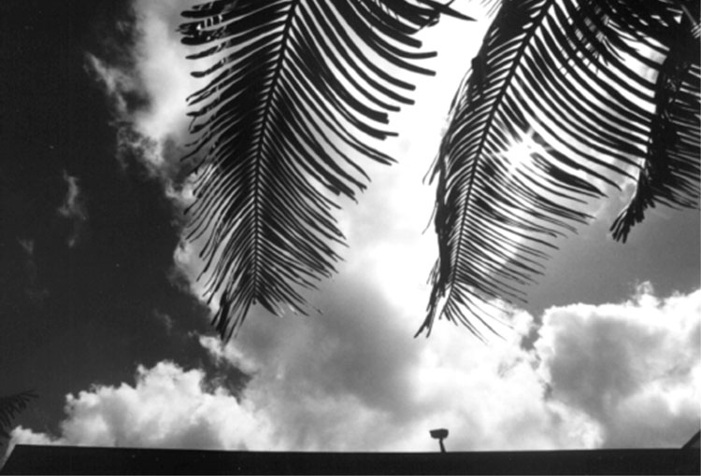
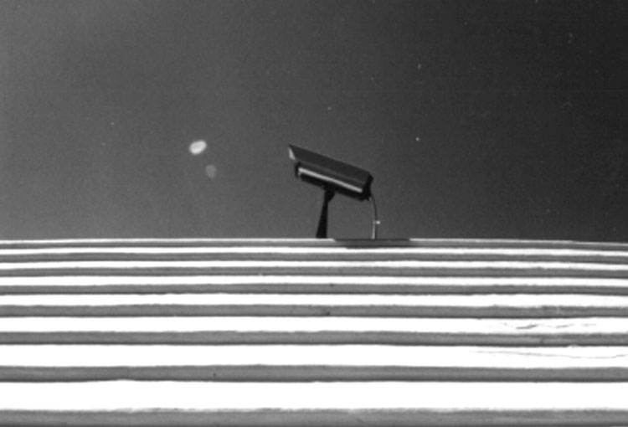
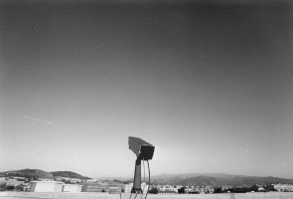
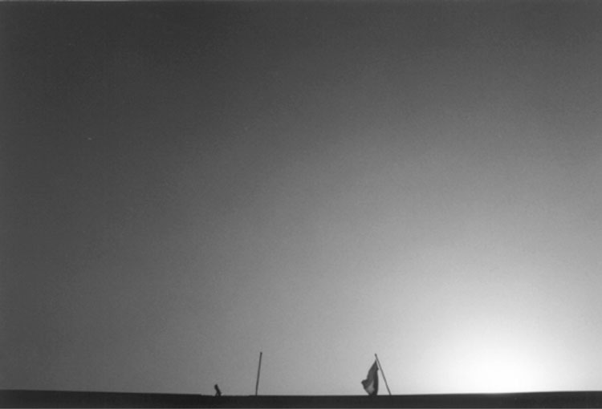
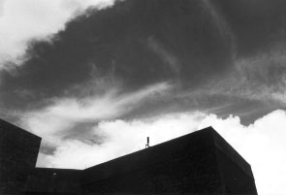
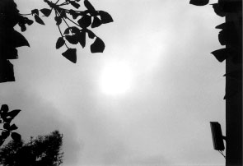
since 23.2.1999
The Time-Eye of HawaiI
Maui Community College / University of Hawaii
310 W. Ka'ahumanu
Kahului, HI 96732-1617 Maui / Hawaii / USA
since 11.4.2000
The Time-Eye of Cairo
Ain Shams University Cairo
Abassia 11566
11566 Cairo, EG

since 19.8.1999
The Time-Eye of Bermuda
Bermuda Underwater Exploration Institute
PO Box HM1745, Hamilton
HM GX Bermuda, GB
since 17.6.2000
The Time-Eye of New Orleans
University of New Orleans
Lake Front
LA 70148-2950 New Orleans, USA

since 16.9.1999
The Time-Eye of Granada
Universidad de Granada
Escuela Técnica Superior de Ingeniería Informática
Avda. de Andalucia 38, 18071 Granada, E
since 23.6.2000
The Time-Eye of Ensenada
Universidad Autónoma de Baja California -
Unidad Ensenada / Ubicación: KM 103 Carr.
MX-22870 Ensenada, B.C., MX

INPLUSION

Time-Eyes operational

INPLUSION

Time-Eyes operational

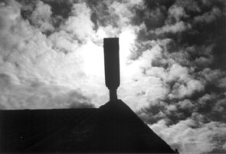
since 11.7.2001
The Time-Eye of the azores
University of the Azores
Terra Chá 9701 - 851
9701- 851 Angra do Heroismo / Terceira / Azores / P
Since 12.2.2002
The Time-Eye of DUBAI
Zayed University Dubai
P.O. Box 19282
Dubai / UAE

Since 19.3.2003
The Time-Eye of Hong kong
Hong Kong University of Science and Technology
Kowloon / Clear Water Bay
Hong Kong / China

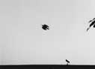
since 10.1.2004
The Time-Eye of KOLKATA
Jadavpur University Kolkata
Salt Lake City, Block-LB, Plot No. 8
700 091 Kolkata / IND

since 14.2.2005
The Time-Eye of TOKYO
Kanazawa Institute of Technology - Tokyo
1-15-13 Jingumae, Shibuya-ku
Tokyo 150-0001 / JPN

since 24.8.2006
The Time-Eye of THE MARSHALL ISLANDS
College of the Marshall Islands
P.O. Box 1258, MH 96960
Majuro / Republic of the Marshall Islands - RMI
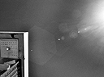
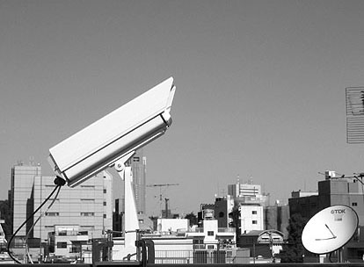

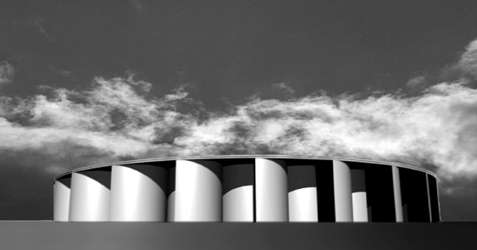
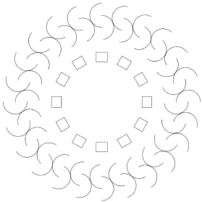
computer graphics by Hofstetter Kurt © parallel media

EXPLOSION

Station Φ, type and structure by Hofstetter Kurt, 2001
The Sun is public … knowing no difference between day or night.
The Sunpendulum Station Φ is public, open 24 hours and accessible from all directions. The Circle – the basic element of Sunpendulum's structure and movement – dictates the geometry of the Station Φ.
24 pairs of half cylinders are set up in a circle and form entry points in all directions. Adjacent concavities are shifted in parallel by the radius of the semicircular profile and the corresponding convexities touch each other.
Their particular form – – resembles the symbol for "universal brotherhood" of the Hopi Indians*), which are touching each other and thus closing a circle. This shell protects the inner space against daylight – no light beam is directly reaching the inner circle of the screens. The distance between opposing screens has been fixed at 6 meters, forming an intimate space.
An Iris of Solar cells on the roof receives the light of the sun and produces all the necessary energy.
*) Carl G. Liungman, Dictionary of Symbols, 1991, p 175

COOPERATION

September 2006

TEAM
Katja Bühler scientist circum c – management
Barbara Doser media artist II media -presentation,documentation,reflection

Andreas Doser architect pavilion#2 – modelling & construction issues

Michael Gervautz a.o. professor* research
Georg Graf scientist kernel – sys-admin, 'ATESI' program
Reinhard Haslwanter architect pavilion#1 – cooperation in architecture, model
Hermann Hauke blacksmith pavilion#2 – modelling & construction issues
Bob Hewis writer compass – forum & interlinguistic affairs
Hofstetter Kurt media artist artistic director of the project:
concept, architecture, research, II media
Peter Jauernig biologist quality assurance
Christoph Kainzner manager management assistance
Martin Kerchler scientist software - development
Maria Bettina Kuprian market researcher international coordination – ANTO
Helmuth Locher engineer engineering, statics
Stephan Mantler scientist kernel – research, software development
Marcus Priesch scientist kernel – hardware issues, watchdog program
Werner Purgathofer professor * research coordination
Herbert Schwabl software developer www projects – software development
Peter Stieglecker scientist www projects – development
Christoph Traxler scientific staff* research communication
* Institute of Computer Graphics and Algorithms / Vienna University of Technology;

COLLABORATION
Maui Community College – University of Hawaii, USA
Bermuda Underwater Exploration Institute, GB
University of Granada, E
Ain Shams University Cairo, ET
University of New Orleans, USA
University of Baja California - Ensenada, MEX
University of the Azores, P
Zayed University Dubai, UAE
Hong Kong University of Science and Technology, PRC
Jadavpur University Calcutta, IND
Kanazawa Institute of Technology, JPN
College of the Marshall Islands, RMI

SUPPORT
Austrian Federal Chancellory / Department for the Arts, Austrian Federal Ministry for Education, Science and Culture, Austrian Federal Ministry for Foreign Affairs, The City of Vienna / Cultural Department, Austrian National Tourist Office, Austrian Trade Delegation, Telekom Austria, Austrian Cultural Institute - New York, Institute of Computer Graphics and Algorithms / Vienna University of Technology, :3C! Creative Computing Concepts, BekoNet Ing. Kotauczek, Vienna Guest Apartments Bermuda, Austrian Airlines, Boblbee, Hotel Imperial Vienna, Pammer Druck, Rainbow Tours

o b j e c t h o f s t e t t e r – media art studio, Langegasse 42/3.2, 1080 Vienna – Austria
phone | fax: ++43 / 1 / 95 75 848 , email: hofstetter@sunpendulum.at, InterNet: http://www.sunpendulum.at
HOFSTETTER KURT
born on July 16th, 1959 in Linz, concept- and media artist, living and working in Vienna.

artistic domains: concepts, sound-compositions, mathematical reflections, light sculptures, computer & video installations, InterNet sculptures, time sculptures, media art installations in public space

PERMANENT MEDIA INSTALLATIONS IN PUBLIC SPACE
2006 sunpendulum time-eye of the Marshall Islands College of the Marshall Islands – RMI Majuro
2006 TIME DE LUX Medienkunstlabor / Kunsthaus Graz Graz
2005 sunpendulum time-eye of Tokyo Kanazawa Institute of Technology – Japan Tokyo
2004 sunpendulum time-eye of Kolkata Jadavpur Universioty Kolkata – India Kolkata
2003 sunpendulum time-eye of Hong Kong HK University of Science & Technology -China Hong Kong
2002 sunpendulum time-eye of Dubai Zayed University Dubai - United Arab Emirates Dubai
2001 sunpendulum time-eye of the Azores Universidade dos Acores - Portugal Angra Heroismo
2000 sunpendulum time-eye of Ensenada Universidad de Baja California - Mexico Ensenada
2000 sunpendulum time-eye of New Orleans University of New Orleans Nerw Orleans
2000 sunpendulum time-eye of Cairo Ain Shams University Cairo Cairo
1999 sunpendulum time-eye of Granada Universidad de Granada - Spain Granada
1999 sunpendulum time-eye of Bermuda Bermuda Underwater Exploration Institute Bermuda
1999 sunpendulum time-eye of Hawaii Maui High Performance Computing Center Maui /Hawaii
1994 one moment of time railway station "Vienna South" Vienna
1993 planet of the commuters with the 3 time-moons rail & sub station "Landstraße - Vienna Middle" Vienna

MEDIA INSTALLATIONS (selection)
2007 SPACING TIME | solstice 2007 @ paraflows 07 MAK-CAT Flakturm Arenbergpark Vienna
2007 single field - installation Landpartie 2, NÖ - Austria Unter-Oberndorf
2007 RAUMKUSS – light/sound installation Forum Experimentelle Architektur / MQ Vienna
2007 TWILIGHT PENDULUM – space installation TENT Witte de With / IFFR exhibition Rotterdam
2006 TWILIGHT PENDULUM – sculpture ZKM – Museum for Contemporary Art Karlsruhe
2005 X-tense images – FTE-, CLP - sculptures KIT - Future Design Institute Tokyo
2005 ‘C light pendula’ sculpture Triennale New Delhi – India New Delhi
2004 ‘C light pendula’ www-client http://www.sunpendulum.at/clp/ WWW
2003 ‘pupils are not black holes’ G-Town Vienna Vienna
2002 ‘facing time eyes’ www-client http://www.sunpendulum.at/fte/ WWW
2001 ‘facing time eyes’ 1st installation look around, Medienwerkstatt Wien Vienna
2000 ‘as time goes b-eye’ sunpendulum reflection, Egyptian Embassy Vienna
1999 ‘lips pendulum’, ‘complementary light pendulum’ II=0, Echoraum Vienna
1998 ’moments in communication’ Sarajevska Zima / internat. art festival Sarajevo
1997 ‘die Zeit pendelt durch den Raum’ Arbeit Buch Wissenschaft, Arbeiterkammer Vienna
1997 ‘the smile that you send out returns to you’ TopCall, stock market Vienna
1996 ‘moments underway’ art cards in Euro-City trains Europe
1996 ‘moving moments @ pendel’ "Schrägspuren" - international video festival Klagenfurt
1996 ‘moving moments @ pendel’ 100 Years Cinema, Art Hall Vienna Vienna
1996 ‘moving moments @ pendel’ internat. Festival - Media Scape 4 Zagreb
1992 ‚time-eye’ Im Augenblick, Haus Wittgenstein/Thurn&Taxis Vienna/Bregenz
1991 ‘Explosion – Inplusion’ light installation, Skala Vienna
1990 ‘Samples & Pictures’ in HPC Industry 90, fair area - Hannover Hannover
1989 ‘Hofstetter Pendulum Clockwork’ (HPC) World Tech Vienna, Austria Center Vienna Vienna
WORKSHOPS / SYMPOSIA / LECTURES (selection)
2006 Vienna University of Music / Institute of Music Theory – lecture ‘the Archiquant’ w. H. Gerngross Vienna
2005 Kanazawa Institute of Technology / Media-Arch. – lecture ‘Sunpendulum - artistic intentions’ Kanazawa
2003 Conference “The Unifying Aspects of Cultures” – lecture “time ? experience” Vienna
2002 University of Vienna / Pulizistik – lecture ‘video moments with eastern artists’ Vienna
2002 European Symposium on Solar Architecture – ‘the Sunpendulum pavilion #2 / solar cells’ Vienna
2002 Zayed University Dubai – lecture ‘Sunpendulum - artistic details’ Dubai
2001 Medienwerkstatt Wien – talk ‘moebius tape in terms of time & sound’ Vienna
2001 Museum of Modern Art – East&East split reality ‘artistic communication – former yugoslavia’ Vienna
2001 Summer Academy Riczsovary – workshop ‘moments in communication’ / Hungary Ricszovary
2000 University of New Orleans – lecture ‘Sunpendulum - artistic details’ New Orleans
1999 University of Vienna / Institute for Cybernetics – lecture ‘the sunpendulum project’ Vienna
1999 Summer Academy Topolcianky – workshop ‘moving moments’ / Slovakia Topolcianky

COOPERATIONS (selection)
Since 1997 sunpendulum architecture, research and parallel media – work with the sunpendulum team in progress
1997 Luminers Call - Date 1 media performance
with Barbara Doser European Cultural Month 1997 Ljubljana
1996 pendel- datapool of moments
with Ars Electronica Center since 1996 a www-residence project WWW / Linz
1996 moving moments 96 exchange of video moments via InterNet
with Doser / Math Sarajevo - Vienna WWW
1995 frame 04199401.0-4 video-infrared-sound-installation
with Doser / Math Museum of Applied Arts - MAK Vienna
1995 Changing Messages Parallel Crossover telematisches Radio-Live-Event
with Doser / Math TRANSIT ORF-Art Radio/ Radio Sarajevo Innsbruck
1994 Mreza/Netz telephone concert in Ljubljana, Belgrade, Pula
with the project group Mreza/Netz Sarajevo, Skopje and Vienna; Remise-Vienna Vienna
1993 Against Violance dance, video- and sound performance
with Zabelka, Doser, Uveric, Carneiro, Kotterer subway station Vienna-Middle Vienna

VIDEO-, SOUND- & PROJECT PRESENTATIONS with Barbara Doser in more than 25 countries (selection: int. film festival Rotterdam, ‘short cuts cologne’/Köln, int. video festival / Kansk, New York independent film and video festival, Film+Arc 1/Graz, Ostranenie/Dessau, Next Five Minutes / Amsterdam, Biennale/St.Petersburg, Media Wave/Györ ... )

VIDEOGRAPHY (selection)
with Barbara Doser:
2007 'dream’sdreams', mini DV, b&w, 13 min, experimental
2006 'order-re-order', mini DV, b&w, 7 min, experimental
2005 'you breathe life into my bosom, Oleander', mini DV, b&w, 10 min, experimental
2003 'SUNPENDULUM by Hofstetter Kurt', mini DV, colour, 16 min, project video
2002 'facing time. parallel in an orbit', mini DV, b&w, 12:12 min, experimental
2001 'runtime one', mini DV, b&w, 4:40 min, experimental
1998 'SUNPENDULUM by Hofstetter Kurt', mini DV, colour, 16 min, project video
1995 'cross over', HI8, colour 7:15 min, experimental | music
with Barbara Doser & Norbert Math:
1995 'Mreza/Netz - a memory of the live event in Vienna', HI8, 20 min, colour and b&w, pal, stereo, documentary |
music
AMONG OTHER THINGS

scientific papers:
2006 “A 4-step construction of the golden ratio” in Forum Geometricorum -
http://forumgeom.fau.edu/FG2006volume5/FG200618index.html
2005 “Division of a Segment in the Golden Section with Ruler and Rusty Compass” in Forum Geometricorum -
http://forumgeom.fau.edu/FG2005volume5/FG200518index.html
2004 “Another 5-step Division of a Segment in the Golden Section” in Forum Geometricorum -
http://forumgeom.fau.edu/FG2004volume4/FG200402index.html
2003 “A 5-step Division of a Segment in the Golden Section” in Forum Geometricorum -
http://forumgeom.fau.edu/FG2003volume3/FG200322index.html
2002 “A simple construction of the Golden Section” in Forum Geometricorum -
http://forumgeom.fau.edu/FG2002volume2/FG200208index.html

- book project “Einen Augenblick Zeit – Parallaxe” - Verlag “edition selene” – ISBN 3-85266-262-1
http://www.selene.at/buchdetail.php?id=147&show=neuerscheinung

1993 protection by patent of the Republic of Austria for the "Hofstetter Pendulum Clockwork" -
permanent installation in the Historical Museum of Vienna
- Brunel Award Commendation - Copenhagn - international award for the permanent media installation at the
railway station "Landstraße - Vienna Middle" „planet of the commuters with the three time-moons“

